**Kelompok : Ikbar Nur Muhammad 1127050071 IF D**

**Fahmi Ahmad Jauhary 1127050052 IF C**

Use Case Diagram

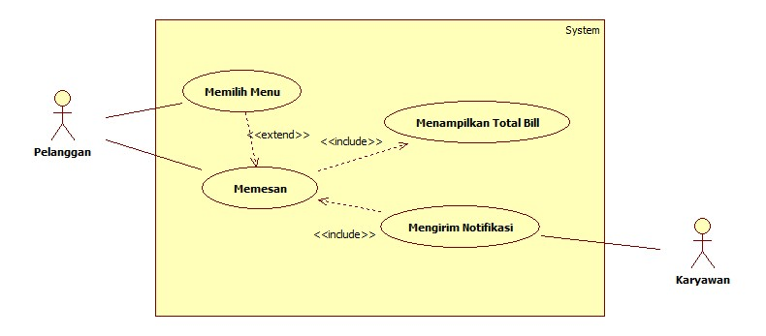

Class Diagram

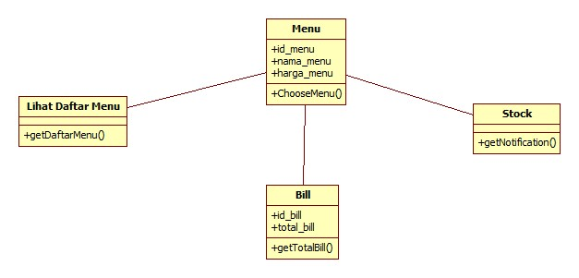

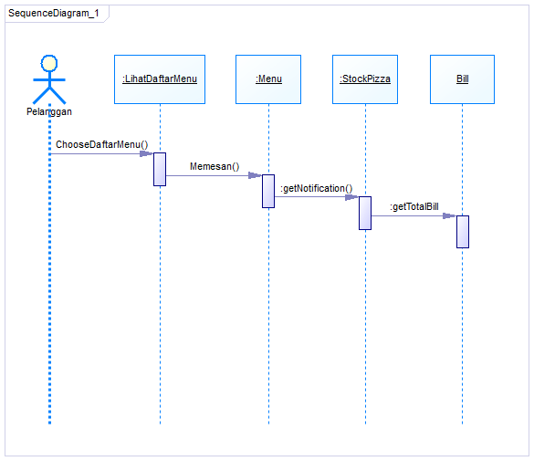Sequence Diagram